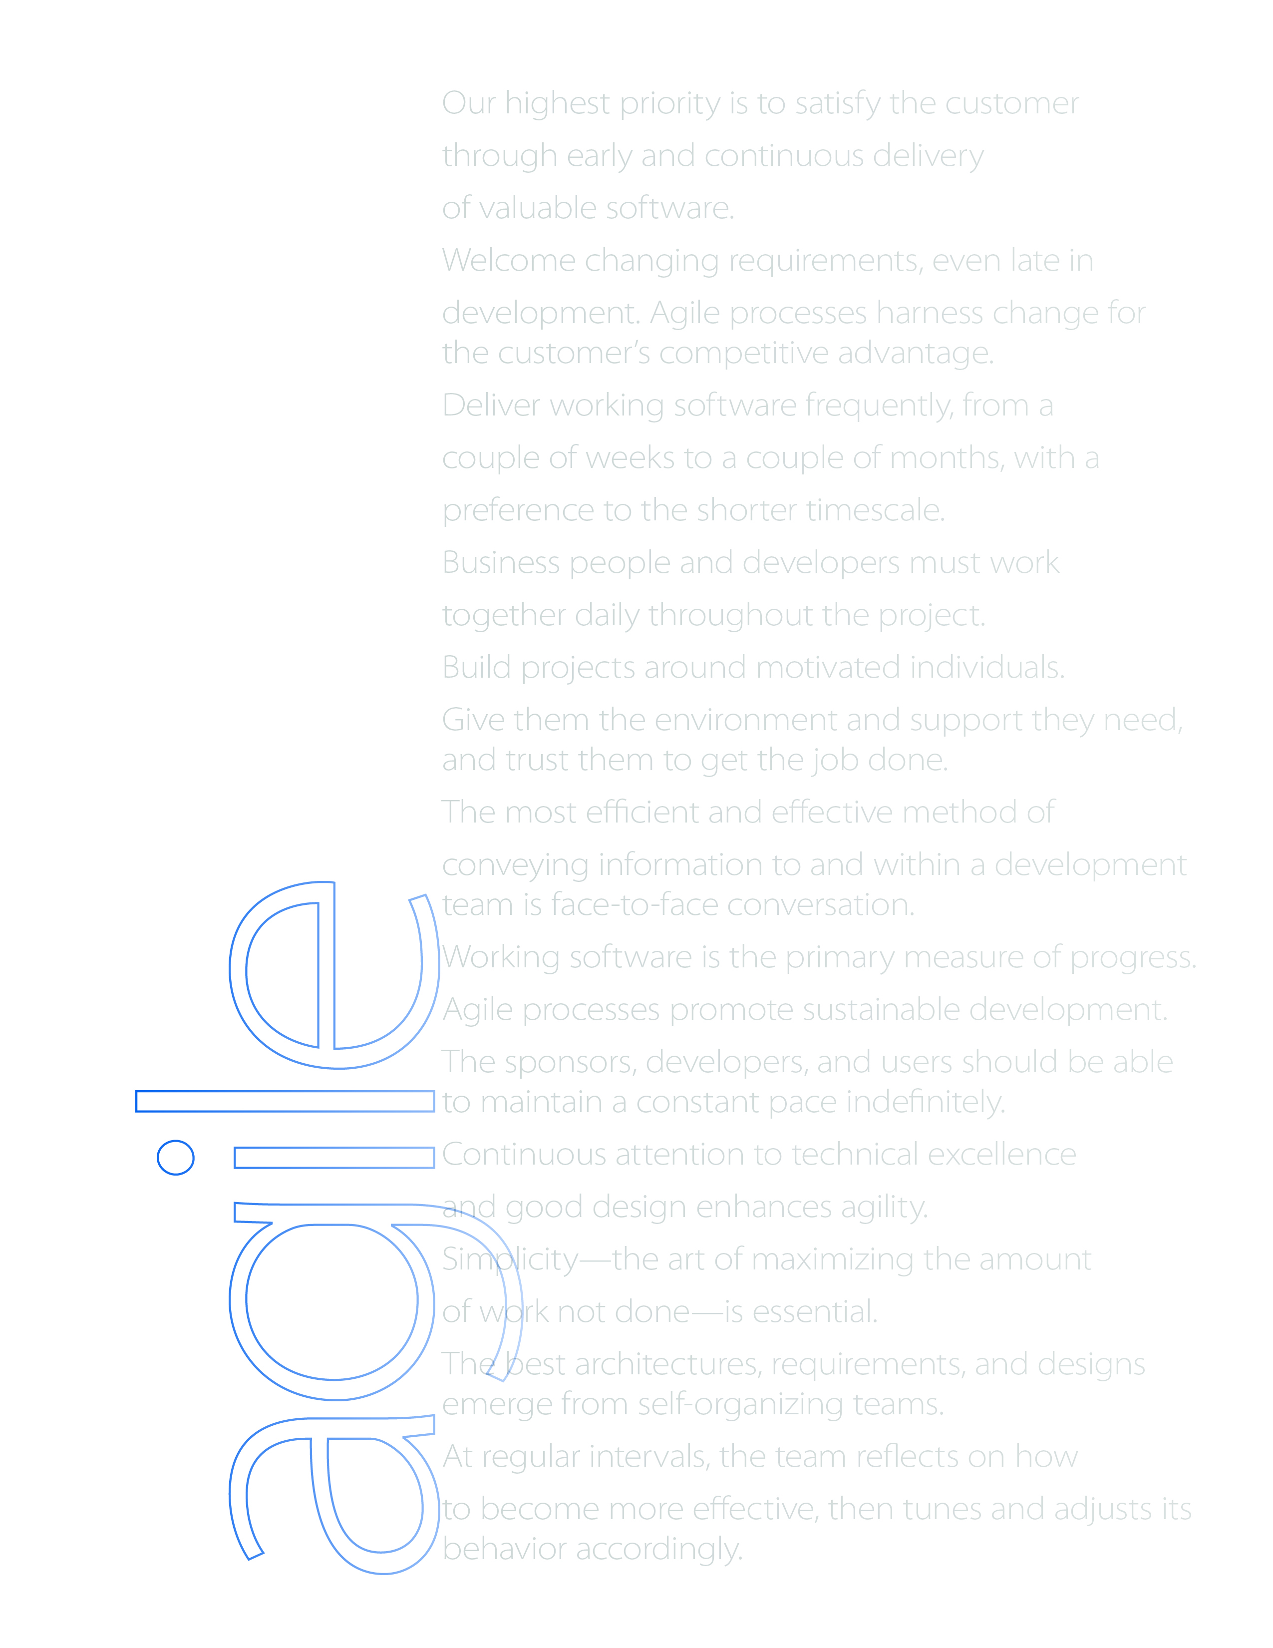

Certiﬁed ScrumMaster Course

Workbook

Name:

# Course Agenda

This course is not organized traditionally. During the first afternoon, you, the course participants, will collaboratively prioritize the possible course topics and select the topics that are most highly valued on this particular course.

However, some topics are ”musts”, because we will have to cover those in order for the course to be a certified ScrumMaster course. These ”must” topics are:

* **Agile Thinking** – *Agile values, 12 principles, predictable vs. Complex systems*
* **Scrum Framework** – *Meetings, roles, artifacts, self-organization, emergence*
* **Product Vision** – *Importance of vision to product success, testing templates*
* **Release Planning** – *Basic techniques for creating longer term plans*
* **Sprint Planning and Execution** – *Sprint Planning, Daily Scrums, Sprint Reviews*
* **Retrospectives** – *Importance of Sprint Retrospectives, trying simple techniques*

The optional topics to prioritize from are:

* **Team Formation** – *Stages of team development, ScrumMaster’s role in stages*
* **Writing User Stories** – *writing effective user stories, INVEST criteria*
* **Relative Estimation** – *Basics of relative estimation, practicing Planning Poker*
* **Traditional PM vs. Scrum Roles** – *Examining how PM role maps to Scrum roles*
* **Challenging Situations with Teams** – *Discussing SM role in difficult scenarios*
* **Technical Practices (XP)** – *Overview of the techniques needed to develop Agile code*
* **Estimating Value** – *Different techniques for estimating value, trying one of them*
* **Project Kick-Off Exercise** – *How to kick-off a project effectively, initial release plan*
* **Scaling Scrum** – *Key challenges and techniques for scaling Scrum in a controlled way*
* **Multi-Site Scrum** – *Key challenges and mitigation strategies for distributed Scrum*
* **Managing Maintenance** – *Control strategies for continuous flow of work*
* **Optimizing Work** – *Parallelizing work, reducing work-in-process*
* **Eliminating Waste** – *7 types of waste in product development, values stream mapping*
* **Team Wall Charts** – *Fundamentals of wall charts, what can we read from them?*
* **Agile Contracts** – *How to turn any contract into an Agile contract*
* **Pre-Assignment Wrap-Up** – *Wrapping up the pre-assignment exercises, discussion*
* **Scrum Test** – *Learn what you’ve learnt, not used for determining certification*

There are too many potential topics that about half of them cannot be covered during the course. Additional information to the topics can be found from course material that is delivered after the course.

# Quotes

In your table group, please discuss these quotes. How do you interpret them? How is what they comment related to Agile or Scrum? Or to ourselves?

Write down key notes below each quote. Be prepared to comment on your insights and opinions.

**“There are those who look at things the way they are, and ask why... I dream of things that never were, and ask why not?”**   
 – Robert Kennedy

**“Everything should be made as simple as possible, but not simpler.”** – Albert Einstein

**“Often detail adds no more usefulness – only a false appearance of validity.”** – Edward de Bono

**“The best bang-per-buck risk mitigation strategy we know is incremental delivery.”**

– Tom DeMarco, 2003

**“It is not the strongest or most intelligent of species that survives, but the most adaptable.”** – attributed to Charles Darwin

# Scrum Simulation

In this simulation, we explore the Scrum framework through practice.

The goal is to create a Scrum ”playbook” brochure for those not yet familiar with, or with an unclear understanding,of, the Scrum framework. There are seven stories in the backlog (in separate cards), each with their own acceptance criteria. There will be two Sprints, each of which is to end with a potentially shippable version of the brochure.

The simulation will have the following phases:

* Initial design workshop – 15 minuts
  + In this workshop, the team takes a look at the stories and creates their first ”product design” of the brochure, with a look at contents in general.
* Sprint 1 planning – 15 minutes
  + In Sprint planning, the team looks at the product backlog together with the PO, and select the product backlog items they can commit to delivering. Also, the team designs the sprint outcome in more detail and plans the needed tasks. Tasks are written down on post-it notes and placed on team’s Scrum board.
* Day 1 of Sprint 1 – 15 minutes
  + Daily Scrum – 3 minutes
  + Day 1 – 12 minutes
* Days 2 and 3, following the structure of day 1
* Sprint Review for Sprint 1 – 5 mins per team
  + Teams demonstrate and receive stakeholder feedback for their ”potentially shippable product increment”.
* Sprint Retrospective for Sprint 1 – 5 mins
  + Teams review their process and agree how to work better in Sprint 2.
* Sprint 2 with Sprint Planning, 3 development days and Sprint Review

The teams will plan and track their progress using a Scrum board with the following general appearance:

Done

Ongoing

Development Tasks

Acceptance Criteria

Sprint Backlog

Product Backlog

# Agile Manifesto

Here is the Agile Manifesto (for software development). In the space below the manifesto, you can create a mind map of your insights and notes about it and the discussions.

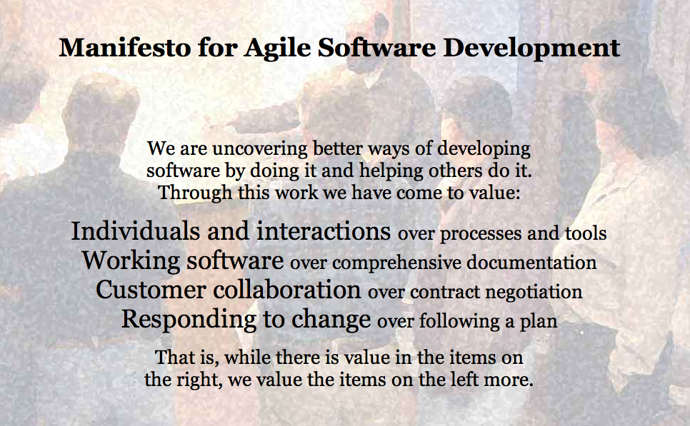

Agile Manifesto

Below are the 12 principles that are part of the Agile Manifesto. In your table group, create “pocket-sized principles” by collaboratively extracting the essence out of each one and condensing that to three words or less.

Our highest priority is to satisfy the customer through early and continuous delivery of valuable software.

Welcome changing requirements, even late in development. Agile processes harness change for the customer's competitive advantage.

Deliver working software frequently, from a couple of weeks to a couple of months, with a preference to the shorter timescale.

Business people and developers must work together daily throughout the project.

Build projects around motivated individuals. Give them the environment and support they need, and trust them to get the job done.

The most efficient and effective method of conveying information to and within a development team is face-to-face conversation.

Working software is the primary measure of progress.

Agile processes promote sustainable development. The sponsors, developers, and users should be able to maintain a constant pace indefinitely.

Continuous attention to technical excellence and good design enhances agility.

Simplicity--the art of maximizing the amount of work not done--is essential.

The best architectures, requirements, and designs emerge from self-organizing teams.

At regular intervals, the team reflects on how to become more effective, then tunes and adjusts its behavior accordingly.

# Complexity and Causality

Quoting from <http://www.noop.nl/2008/08/simple-vs-complicated-vs-complex-vs-chaotic.html>,

### My car key is simple.

It took me about three seconds to understand how my car key works. OK, maybe that's not quite correct. Mine has a battery in it. If I take it apart it might take me another three hours to understand its details. But yeah, I'm smart, I'll manage.

### My car is complicated.

It would take me years to understand how my car works. And I don't intend to. But if I did, then some day in the far future I would know with certainty the purpose of each mechanism and each electrical circuit. I would fully understand how to control it, and I would be able to take my car apart and reassemble it, driving it exactly as I did before. In theory, of course. In practice, only real men do things like that.

### Car traffic is complex.

I can travel up and down the same street for twenty years, and things would be different every time. There is no way to fully understand and know what happens around me on the road when I drive, how other drivers operate their vehicles, and how the people in the streets interact. I can make guesses, and I can gain experience in predicting outcomes. But I will never know for sure.

### Car traffic in Lagos (Nigeria) is chaotic.

When things get too complex, they easily become chaotic. Traffic in Lagos is so bad, it is not even predictable. Poor infrastructure and planning, heaps of waste, pollution, lack of security, floods, and many more problems make it one of the worst places in the world to be, as a simple car driver.

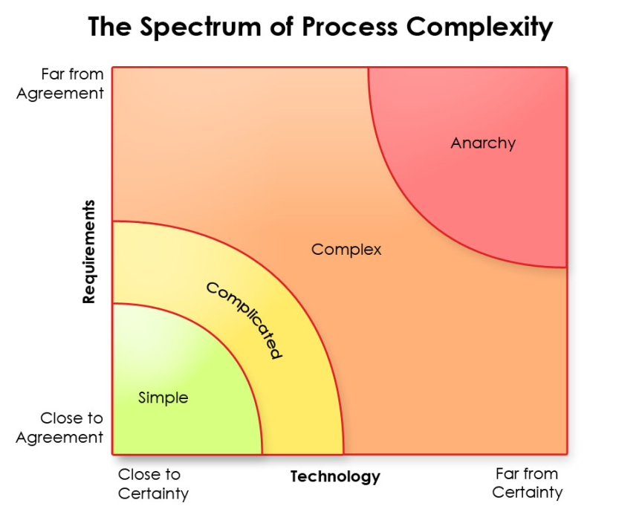

Discuss in 3-4 person groups what each of these categories mean

Then, brainstorm in 3 minutes as many examples to each of the categories as you can. Try to find examples that are related to your working environment.

# The Big Picture

As this topic is discussed, update the diagram below with conceptual levels and elements that are related to each level.



# Scrum ROles vs. Traditional Project Manager

In small groups, discuss the different kinds of responsibilities and activities traditional project managers typically have. Then discuss how those responsibilities and activities would map to Scrum roles. Please write your mapping to the diagram below.

MCj02403610000[1]MCj01861720000[1]

Product Owner responsibilities

ScrumMaster responsibilities

Responsibilities not related to Scrum

Development Team responsibilities

# Team Formation

From Wikipedia on Forming, Norming, Storming, Performing:

**Forming**

In the first stages of team building, the forming of the team takes place. The individual's behavior is driven by a desire to be accepted by the others, and avoid controversy or conflict. Serious issues and feelings are avoided, and people focus on being busy with routines, such as team organization, who does what, when to meet, etc. But individuals are also gathering information and impressions - about each other, and about the scope of the task and how to approach it. This is a comfortable stage to be in, but the avoidance of conflict and threat means that not much actually gets done.

The team meets and learns about the opportunities and challenges, and then agrees on goals and begins to tackle the tasks. Team members tend to behave quite independently. They may be motivated but are usually relatively uninformed of the issues and objectives of the team. Team members are usually on their best behavior but very focused on themselves.

The forming stage of any team is important because, in this stage, the members of the team get to know one another, exchange some personal information, and make new friends. This is also a good opportunity to see how each member of the team works as an individual and how they respond to pressure.

**Storming**

Every group will then enter the storming stage in which different ideas compete for consideration. The team addresses issues such as what problems they are really supposed to solve, how they will function independently and together and what leadership model they will accept. Team members open up to each other and confront each other's ideas and perspectives. In some cases storming can be resolved quickly. In others, the team never leaves this stage. The maturity of some team members usually determines whether the team will ever move out of this stage. Some team members will focus on minutiae to evade real issues.

The storming stage is necessary to the growth of the team. It can be contentious, unpleasant and even painful to members of the team who are averse to conflict. Tolerance of each team member and their differences needs to be emphasized. Without tolerance and patience the team will fail. This phase can become destructive to the team and will lower motivation if allowed to get out of control. Some teams will never develop past this stage.

**Norming**

The team manages to have one goal and come to a mutual plan for the team at this stage. Some may have to give up their own ideas and agree with others in order to make the team work. In this stage, all the team members takes the responsibility and have the ambition to work for the success of the goals of the team.

**Performing**

It is possible for some teams to reach the performing stage. These high-performing teams are able to function as a unit as they find ways to get the job done smoothly and effectively without inappropriate conflict or the need for external supervision. Team members have become interdependent. By this time they are motivated and knowledgeable. The team members are now competent, autonomous and able to handle the decision-making process without supervision. Dissent is expected and allowed as long as it is channeled through means acceptable to the team.

# Product Vision

As examples of how a vision can be effectively created and communicated, here are three different approaches/tools:

#### Geoffrey Moore’s template from Crossing the Chasm:

For *(target customer)*

Who *(statement of the need or opportunity)*

The *(product name)* is a *(product category)*

That *(key benefit, compelling reason to buy)*

Unlike *(primary competitive alternative)*

Our product *(statement of primary differentiation)*

#### Product Box

Design the cover (or the whole box) of an imaginary product box, in which the product would be shipped out in. For services or products without a box, just imagine it would be delivered in one. The box cover should have:

* The name of the product
* An image or logo of the product
* 3-4 key features (and no more than that)

#### User Testimonials

Write three user testimonials that you would like to hear from the actual users after the launch of the product or system. Each testimonial should have:

* One key feature or an important aspect of a central feature
* Description of the way in which the feature was useful to the user
* Name of the user and some description of the user’s type or background

In your table groups, spend a few minutes discussing e.g. the following questions:

* Did the exercise work in clarifying the vision?
* What were the most important and useful part of the exercise?
* Why do exercises like these work? What is important in the exercise itself?

# Release Planning

Let us assume the following simplified Product Backlog (105 story points in total size):

|  |  |
| --- | --- |
| **Story number** | **Size** |
| Story 1 | 3 |
| Story 2 | 2 |
| Story 3 | 5 |
| Story 4 | 5 |
| Story 5 | 3 |
| Story 6 | 8 |
| Story 7 | 5 |
| Story 8 | 13 |
| Story 9 | 13 |
| Story 10 | 20 |
| Story 11 | 8 |
| Story 12 | 20 |

The team has been working on the product for already several sprints and has established probable velocity between 7 and 10. The next release is 7 sprints into the future.

* What is the scope that the PO can commit to stakeholders with reasonable safety?
* Which stories can pretty much be ruled out of probable release scope?

Draw two lines into the Product Backlog to indicate the above two scope limits.

Map the stories (using story numbers) to the following simple release plan.

Stories

Sprint

5-7

3-4

2

1

* How many points worth of stories can you allocate to each sprint “slot”?
* Is this simple method sufficient for release planning? If not, what other things need to be considered?

Consider the following scenarios:

* 2 Sprints forward, the team has delivered up to story 6 (26 more story points). They’ve updated their probable velocity to between 9 and 14. How does this change the release plan?
* User review at the end of Sprint 2 revealed new ideas and requirements that should be incorporated into the release. The team has estimated that their total size is 16. How does this change affect the release plan?

# Sprint Planning and Execution

The iterative and incremental product development cycle in Scrum is managed in three key meetings – Sprint Planning, Daily Scrums, and Sprint Reviews. As we discuss them in more detail, please do write your key insights into the diagram below.

Sprint Planning 1

Sprint Planning 2

Sprint Review

Daily Scrums

Compare your notes with a pair. What kind of differences do you notice? What do you make of those differences?

# Writing User Stories

Typical templates used:

* ***As a*** *<user role>****, I can*** *<do something>* ***in order to*** *<some benefit or purpose>*
* *<User role>* ***can*** *<do something>* ***so that*** *<some benefit or purpose>*

The “can” work can be replaced by “must”, “should”, or any appropriate verb.

Remember, Scrum talks only about “product backlog items” (PBI’s); user stories is just one way of writing a PBI. Also other types of items can be placed in the Product Backlog.

User stories consist of three parts (three C’s):

* **_____________________________________________________________________**
* **_____________________________________________________________________**
* **_____________________________________________________________________**

When writing user stories, the first version of the story can be virtually anything, but as the actual development iteration approaches, it is recommendable to groom them to meet the INVEST criteria:

**I = _____________________________________________________________________**

**N = _____________________________________________________________________**

**V = _____________________________________________________________________**

**E = _____________________________________________________________________**

**S = _____________________________________________________________________**

**T = _____________________________________________________________________**

If you use index cards, it helpful to leave some space to the top and bottom of the card for different attributes, e.g. MoSCoW priority, value, size estimate.



# Relative Estimation

In relative estimation, items are compared against one another rather than against a certain metric. For example, one item maybe considered twice the size of another, rather than estimating how many hours or days it would take to do.

In the diagram below, add any additional notes you think are relevant to this topic.

In table groups, discuss each of the five benefits. What do each of them mean? Do you know some data or information regarding them?

Why Relative Estimation?

Can be estimated with less information

Less affected by differences in skill/experience

Does not ”age” when team’s velocity increases

Separates estimates from commitments

People compare better than estimate

When would time-based estimates be more useful? Where using them would make more sense than relative estimation?

# Challenging Situations with Teams

In table groups, discuss the following scenarios. What kind of issues draw your attention? What “smells” suspicious? What would you do to start resolving the situation?

## Scenario 1

*You are the ScrumMaster and are heading for the team room. The functional analyst runs past you crying and the lead engineer runs past you enraged, both on the way to their functional managers’ offices.*

*You go into the team room. You can cut the tension with a knife it is so thick.*

*Apparently, the analyst has been writing specs and giving them to the engineers, who then change them as they see fit. Anger over this has been building for three weeks.*

*What do you do?*

## Scenario 2

*Before becoming the ScrumMaster, you were a technical lead and respected for your design and programming skills.*

*In your new project, the team comes to you for advice on a challenging architectural choice. The team members have been arguing between two approaches, but could not agree which one to choose.*

*They want you to choose the approach.*

*What do you do?*

## Scenario 3

*You are the ScrumMaster. Everyone on the team except John meets with you. They tell you that John is not doing his work, is offensive, is difficult to work with, and they want you to fix the problem.*

*What do you do?*

# Scaling Scrum

Please add your comments regarding scaling to the diagrams below.



# Technical Practices (XP)

Extreme Programming (XP) forms a solid methodology for development of software systems. Unlike Scrum, it is therefore tied to software development domain. Given that it is assumed that a Scrum team will seek ways in which they can effectively deliver a new tested version of the system in every sprint, it is expected that the team adopt XP or similar technical practices through continuous inspect and adapt cycles. Unfortunately, it is not always the case.

XP consists of a set of development practices, each of which is simple and insufficient in itself, but becomes very powerful when combined with and supported by other XP practices.

The practices, and their key dependencies, are:





Adapted from Janet Gregory’s version of Brian Marick’s original diagram

Functional Test

Examples

Story Tests

Prototypes

Simulations

Exploratory Testing

Scenarios

Usability Testing

User Acceptance Testing

Alpha / Beta

Unit Test

Component Tests

[Test Driven Development]

Performance and   
Load Testing

Security Testing

”-ility” Testing

Manual

Testers

Automated & Manual

Coders and Testers

Automated

Coders

Tools

Coders and Testers, Specialists

Business Facing

Technology Facing

Supporting the Team

Critique Product

# Project Kick-Off

To get a project started, it needs a product backlog that has been sufficiently prioritized to allow the selection of valuable work for the first sprint. One tested sequence of analysis and planning activities, preceded by user story writing, is the following (write your comments and notes to the space below the names of the practices):

## MoSCoW

## Risk / Value Estimation

## Dependency Mapping

## Initial Release Plan

# Managing Maintenance

Scrum is fundamentally a batch-driven approach. It works best when work can be allotted into those batches. However, many environments have rapidly changing priorities and fast response times, and it’s impossible to wait for the next Sprint to act on that in a managed way. Fortunately, there are excellent continuous flow frameworks available.

In the space below, please make notes as we discuss the issue and look at the Kanban framework. You can also draw yourself a simple Kanban board.

# Multi-Site Scrum

In your table group, discuss problems caused by distributing Scrum teams and projects across multiple sites and possibly across multiple time zones.

There are many ways these problems can be mitigated, but the reduced productivity from distribution is very difficult to remove entirely. As we discuss the various possible techniques, write down the key mechanisms below.

Mitigating Multisite

# Optimizing Work

Assuming that the team has three features (A, B, and C) to do, each taking an equal amount of effort and providing equal value to customers, which of the following approaches is the (theoretically) most efficient and least risky way to deliver those features? Why?

A

B

C

A

C

B

A

C

B

A

C

B

A

C

B

In each of the approaches, how would you calculate the amount of value delivered?

In your table group, discuss the key risks and challenges in each of the approaches. In what kind of situations would you select them?

How does this relate to the tasks the development team has planned for itself?

# Eliminating Waste

The seven categories of waste (as defined by Tom and Mary Poppendieck, in Lean Software Development):

In your table group, discuss the seven forms of waste and identify at least one example for each category. Then discuss how those wastes could be eliminated (or at least significantly reduced).

# Team Wall Charts

As we go through the following examples of team wall charts together, we’ll discuss what observations you can make in each and what possible problems they highlight.

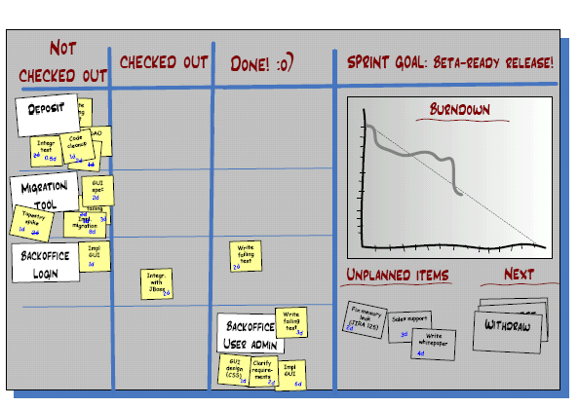

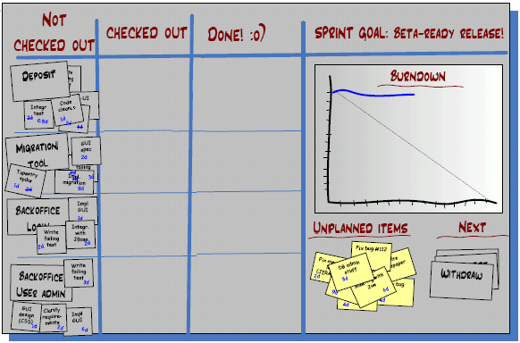

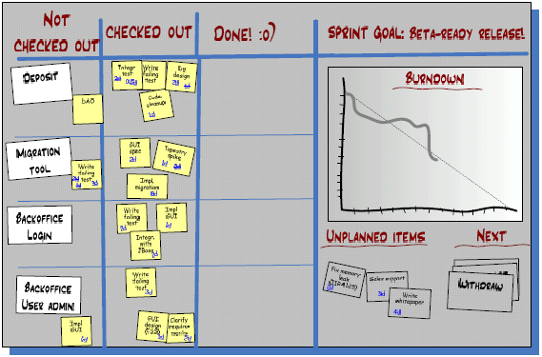

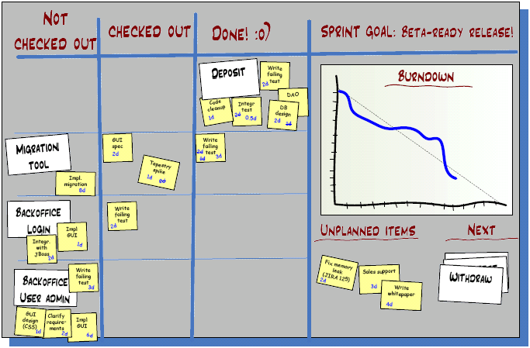

Original copyright for the diagrams: Henrik Kniberg

# Agile Contracts

In my experience, Agile software development can be done using largely the same contracts as traditional development. However, there are certain things that is recommended to be different. The following additions can be added to virtually any contract.

## Definitions

We mutually agree on working together, and thereby build trust in each others expertise.

### Customer Participation in Scrum Team:

The Customer is expected to be active in the project. The role of the Customer includes the following:

* Prioritize features by business value and have them implemented in order of maximum value
* Mutually agreed estimates for all work items. The official representatives of both parties need to agree. This needs to be noted in a signed addendum to the contract for each change.
* Participate in each Sprint planning meeting by discussing the selected features with Company team, including answering questions to provide clarification to the team.
* Participate in writing the conditions of satisfaction for each feature, so the team and client have a shared definition of when a feature is done. These conditions should be completed as part of a user story before any code is written.
* Participate in each Sprint review meeting, and provide timely feedback both for both work-in-progress and completed work.

***To company: Things to ensure are defined in the contract:

* Total value of the contract
* Rates for time and materials billing
* Scope of the contract

## Clause: Early Termination (Money for Nothing)

The Customer may terminate the contract at the end of any Sprint. The standard metric for termination is when the Customer perceives the cost of continuing the project is higher than the additional value received. The Customer will pay Company 20% of the remaining contract value to exercise early termination.

Company commits to delivering 80% of the project scope as high quality by the agreed upon delivery date. High quality is defined by the agreed upon Definition of Done.

This clause can only be enacted if the Customer maintains Participation in the Team Scrum during the project.

In the event that both parties cannot mutually agree on work item estimates or that the Customer does not maintain participation in the Scrum Team, the contract shall revert to a time and materials billing.

## Clause: Change For Free

If the Customer maintains Participation in Scrum Team during the entire project, Customer shall be able to make changes to the Scope without incurring any additional cost if total Scope of contracted work is not changed. New features may be added for free at Sprint boundaries if items of equal scope are removed from the contract.

<http://www.coactivate.org/projects/agile-contracts/money-for-nothing-change-for-free>

In your table group, discuss the impact these two clauses would have on a project contract.

# Retrospective

In your table group, hold a simple retrospective regarding this course. Please select one of the template structures below.

## The Good, The Bad, the Improvement

In this template structure, there are three rounds around the table. On each round, each participant mentions one thing, and only one, that hasn’t been mentioned before.

On the first round, mention something that went well on the course.

On the second round, mention something that didn’t go so well.

On the third round, make a concrete suggestion as to how to improve the course.

Choose someone in the group to act as a record keeper and to write the items down.

## Pluses and Deltas

In this template structure, take a flipchart sheet and draw the figure shown below on it. Alternatively you can mark corresponding areas on your group table.

Using post-it notes, take a minute or two to silently write down two kinds of things, one item per note:

* Things to keep (plusses, i.e. things that were good about the course)
* Things to change (deltas, i.e. things to either modify, stop using, or start using)

Once written, group similar notes together on the diagram. Look at the diagram and discuss what do you see. Any surprises? What issues stand out? What are the key recommendations for modifications?

**Petri Heiramo**

**CollabNet Certified Scrum Trainer (CST) and Agile Transformation Mentor**

I’m particularly interested in looking at Scrum and Agile as a holistic approach to improving the competitiveness of businesses. I find myself often in discussions where I emphasize the need for businesses to focus on generating value (over managing costs) as a means to success. Be it in a project or in an organization, I frequently see dysfunctions where silly savings are made at the cost of significant value. And many times the decision makers are totally unaware of the impact of their decisions. It is this mismatch between intent (to work for the best of the company) and action that I seek to eliminate. When focusing on value, we need to focus on customer delight, job satisfaction and continuous improvement.

I've studied Agile methods actively since Fall 2005. In addition, to leading Scrum and Agile projects, I have been doing Scrum and Agility training and consulting since early 2006. I was certified as Scrum Practitioner in April 2007 and as CST in November 2008.

I have over 10 years of experience in developing software as a developer, project manager, QA manager, ScrumMaster, process developer, coach and trainer – and experience with both the traditional and Agile approaches to software development. I've seen a wide variety of projects, and as a result, have come to appreciate the positive effects of Scrum on the human side of software development. Seeing people enjoy their work again has been my greatest joy in Agile deployments. Of course, seeing a happy and engaged customer is great, too, and so is instilling a new kind of pride and common sense in the work people do.

### **Transform with Experience**

CollabNet’s ScrumCORE™ training division has helped hundreds of companies successfully adopt and scale Scrum and Agile. As the largest Scrum Alliance certified training facility, CollabNet’s Certified Scrum Trainers possess deep experience leading organizations — from small businesses to multinational enterprises — through Agile transformations. With a full range of training services, CollabNet’s ScrumCORE offerings can meet the needs of any organization.  
  
The ScrumCORE team conducts regularly scheduled public courses in major markets throughout North America and Europe, offering ScrumMaster and Product Owner Certification courses. Additionally, CollabNet’s ScrumCORE trainers are available for on-site private coaching engagements. These coaching sessions connect organizations with an experienced Scrum coach, who can lead them through a transformation or help them resolve specific challenges.   
  
For more information, visit <http://www.open.collab.net/training/scrummaster>, or to speak with a training specialist contact [scrumtraining@collab.net](mailto:scrumtraining@collab.net).



CONTACT US

Corporate Headquarters   
8000 Marina Blvd,   
Suite 600   
Brisbane, CA 94005   
United States   
Phone: +1 (650) 228-2500   
Toll Free: +1 (888) 778-9793

Chennai, India Office   
Phone: +91 44 4220-3700

Shanghai, China Office   
Phone: +86-21-61221082

Seoul, Korea Office   
Phone:+82-2-722-8271

Tokyo, Japan Office   
Phone:+81-3-5789-5366

London, UK Office   
Phone:+44 (0) 207-397-8690

Munich,Germany Office   
Phone: +49 (89) 24218-442

www.collab.net

@ 2010-2011 CollabNet, Inc. All rights reserved. CollabNet is a trademark or registered trademark of CollabNet Inc., in the US and other countries. All other trademarks, brand names, or product names belong to their respective holders. 10012010

www.collab.net

@ 2010-2011 CollabNet, Inc. All rights reserved. CollabNet is a trademark or registered trademark of CollabNet Inc., in the US and other countries. All other trademarks, brand names, or product names belong to their respective holders. 10012010

www.collab.net

@ 2010-2011 CollabNet, Inc. All rights reserved. CollabNet is a trademark or registered trademark of CollabNet Inc., in the US and other countries. All other trademarks, brand names, or product names belong to their respective holders. 10012010

www.collab.net

© 2011 CollabNet, Inc. All rights reserved. CollabNet is a trademark or registered trademark of CollabNet Inc., in the US and other countries. All other trademarks, brand names, or product names belong to their respective holders. 012711